**Exercises**

1. **Write a function called simon.says that takes in a character string, and returns that string in all upper case after prepending the string "Simon says: " to the beginning of it.**

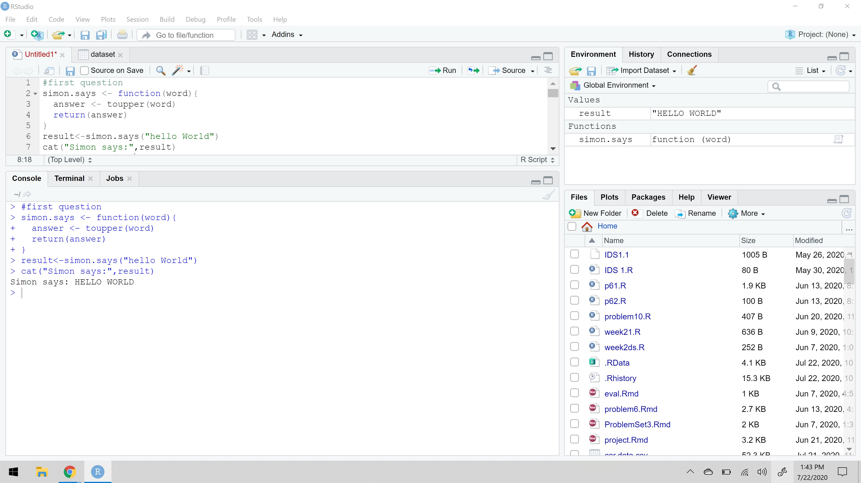

1. **Write a function that takes two matrices as arguments, and returns a logical value representing whether the matrices can be matrix multiplied.**

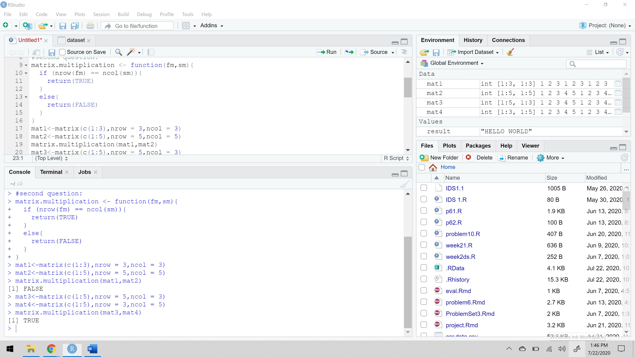

1. **Find a free data set on the web, download it, and load it into R. Explore the structure of the data set.**

* Dim(): this function is useful, because it tells us weather it would be okay to print the entire dataframe to the console.
* Str(): this function tells is the number of rows and columns, but it provides even more information. It tells us the column names, the class of each column and the first few observations of each variable.
* Summary(): this function provides descriptive statistics including the min, max, mean, median and quartiles of each column.
* Colnames(): this function prints a vector of the column names, which can be useful if you’re trying to reference a particular column.
* Head(): this function default to printing the first 6 rows.
* Tail(): this is same as head function except this function prints the end of the dataframe.
* View(): this window provides vertical and horizontal scroll bars for you to browse the entire data set. It looks exactly like excel spreadsheet but you can not manipulate any of the data here.

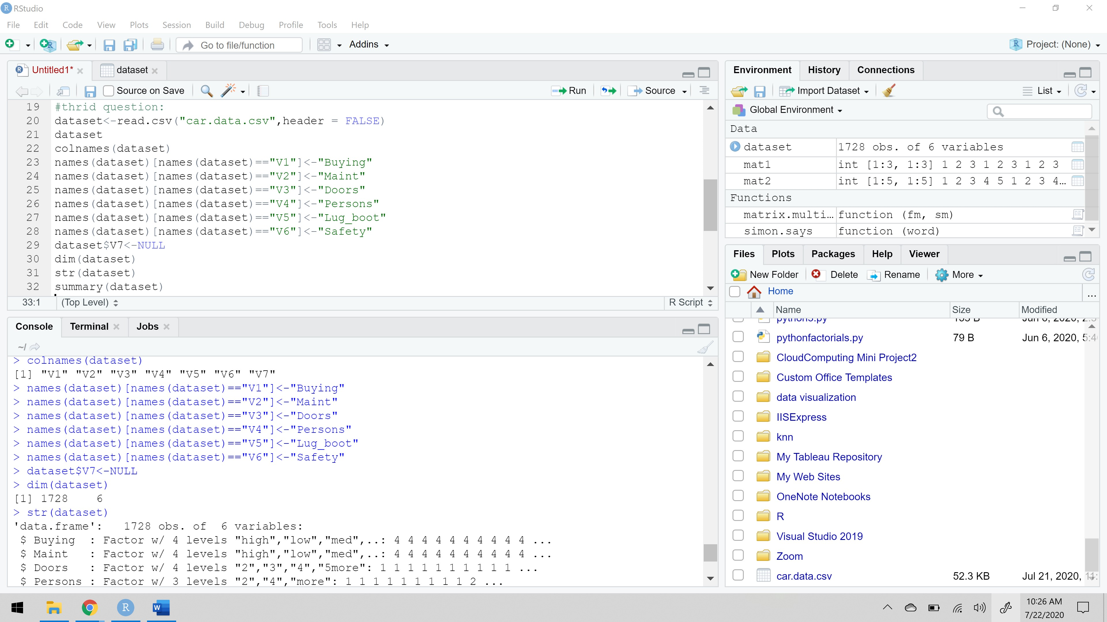

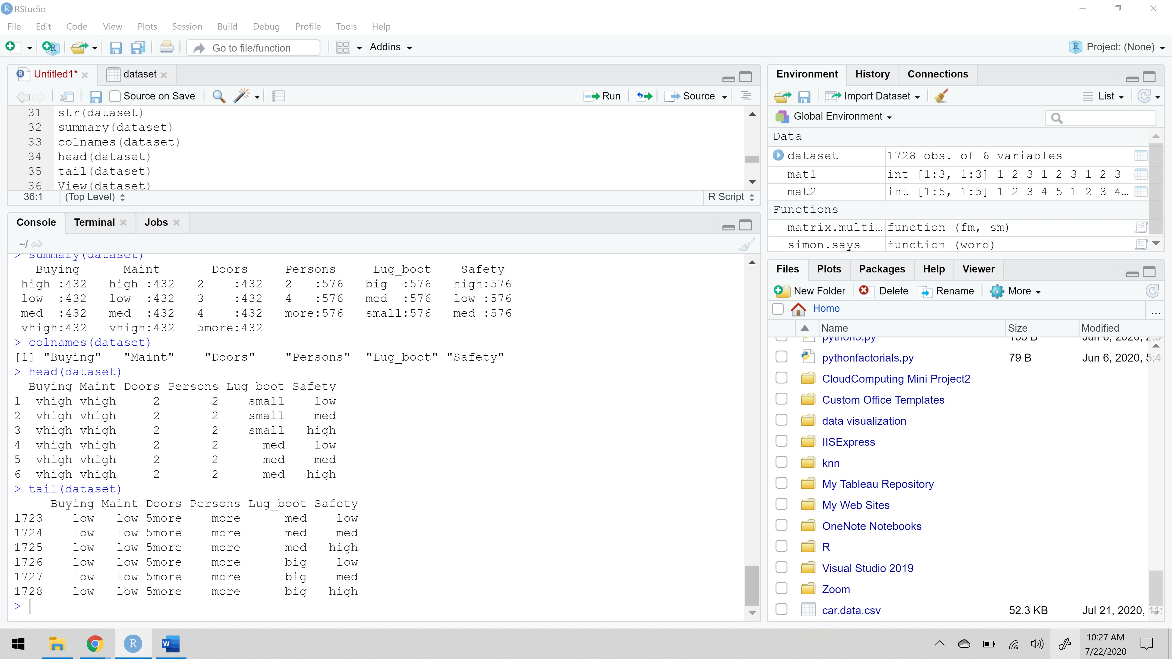

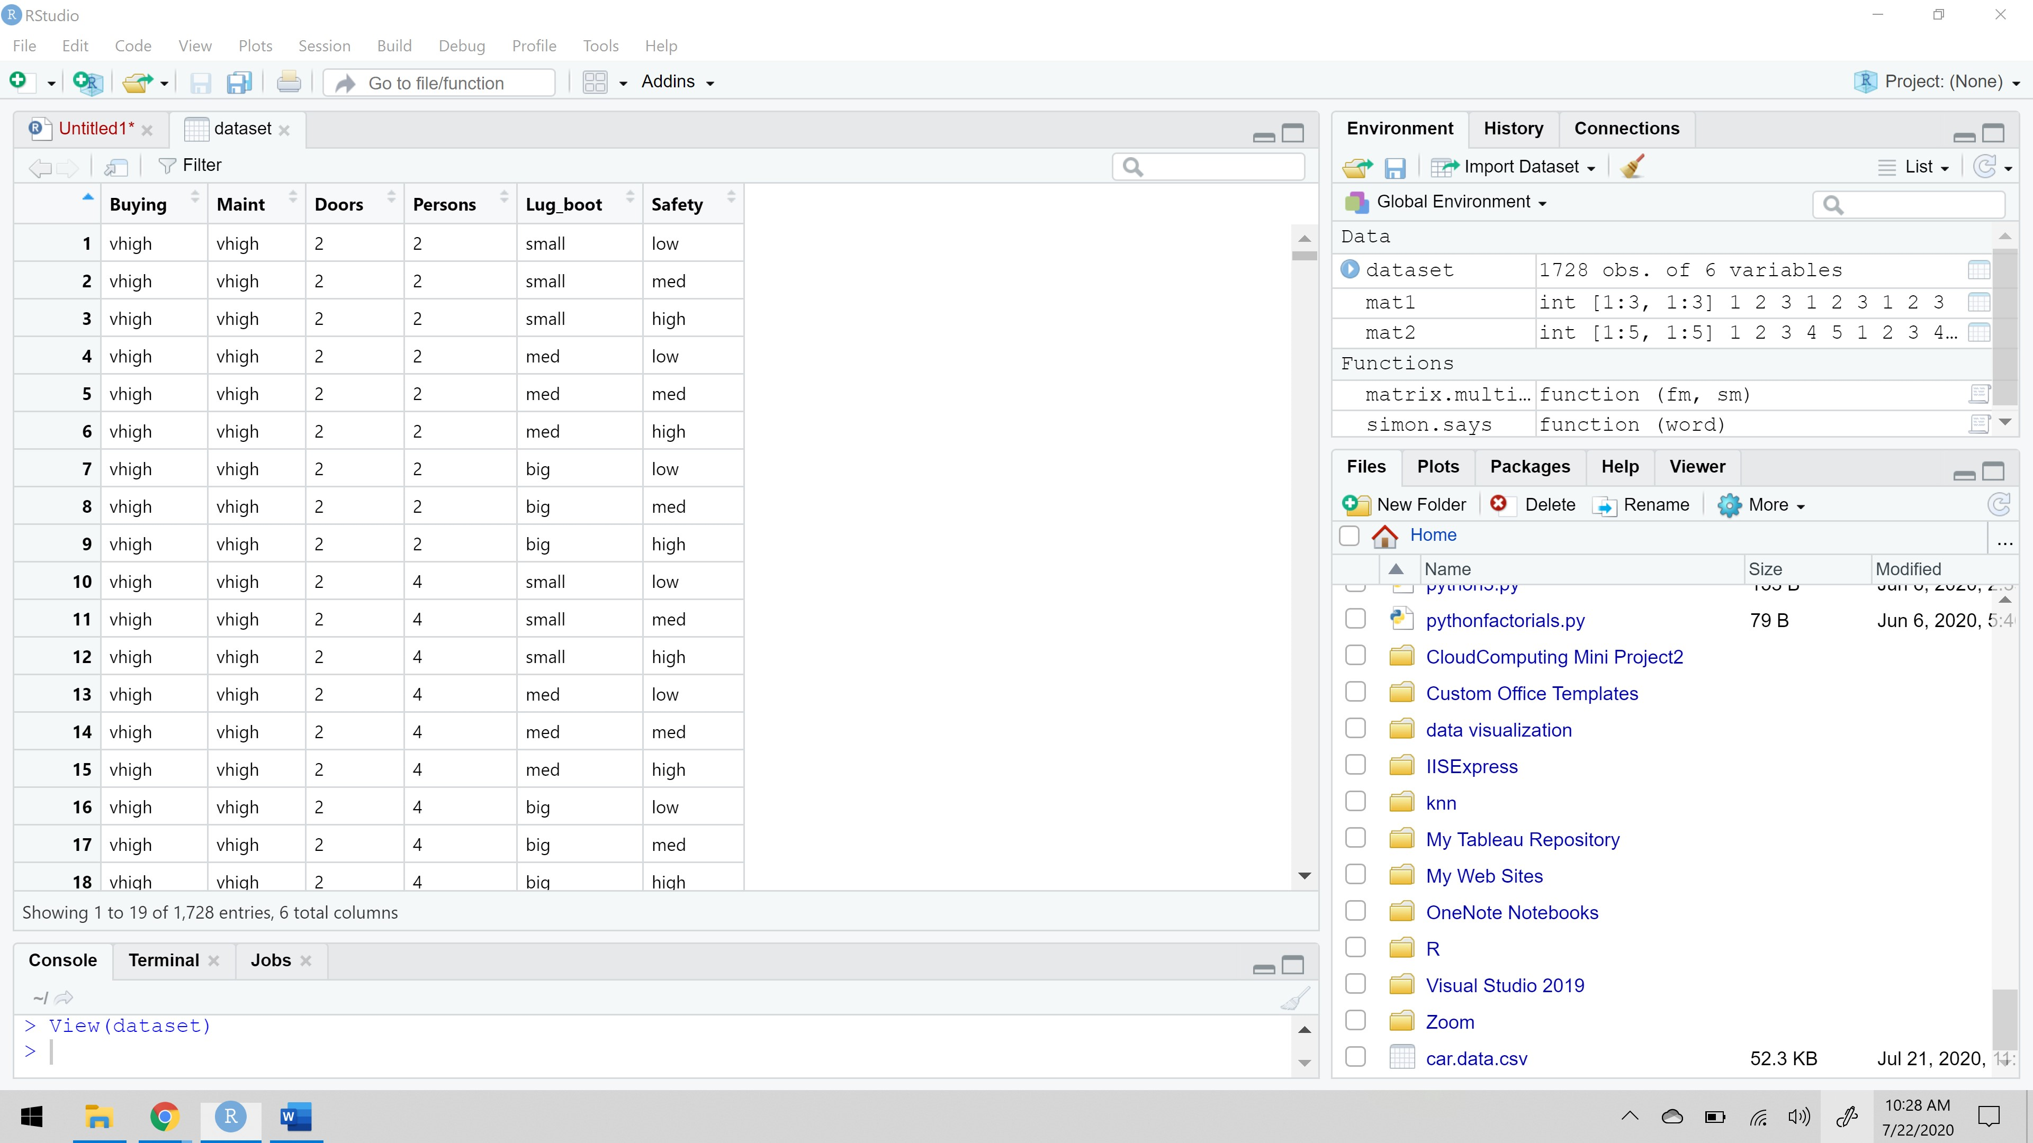

1. **Mean of Positive Values You can simulate values from the normal distribution using the rnorm() function. Its first argument is the number of samples you want, and if you do not specify other values, it will sample from the N(0,1) Normal distribution. Write an R program that takes samples from this function as input, removes the negative values, and computes the mean of the rest. Hint: One way to remove values is to replace them with missing values (NA); if a vector has missing values, the mean() function can ignore them if you give it the option na.rm = TRUE.**

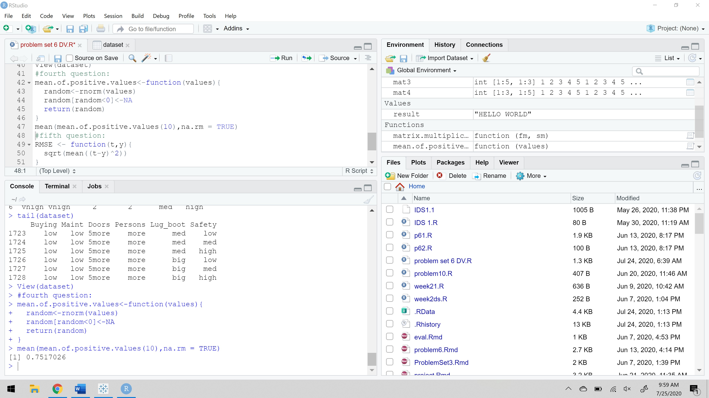

1. **Root Mean Square Error**

**If you have “true” values, t = (t1,…,tn), and “predicted” values, y = (y1,…yn,) then the root mean square error is defined as RMSE(t,y) = $\sqrt{\frac{1}{n}\sum_{i=1}^{n}{{\left(t_{i}-y_{i}\right)}^{2}}}$**

**Write an R program that computes this from a data frame containing the t and y values. Remember that you can do this by first computing the square difference in one expression, then computing the mean of that in the next step, and finally computing the square root of this. The R function for computing the square root is sqrt().**

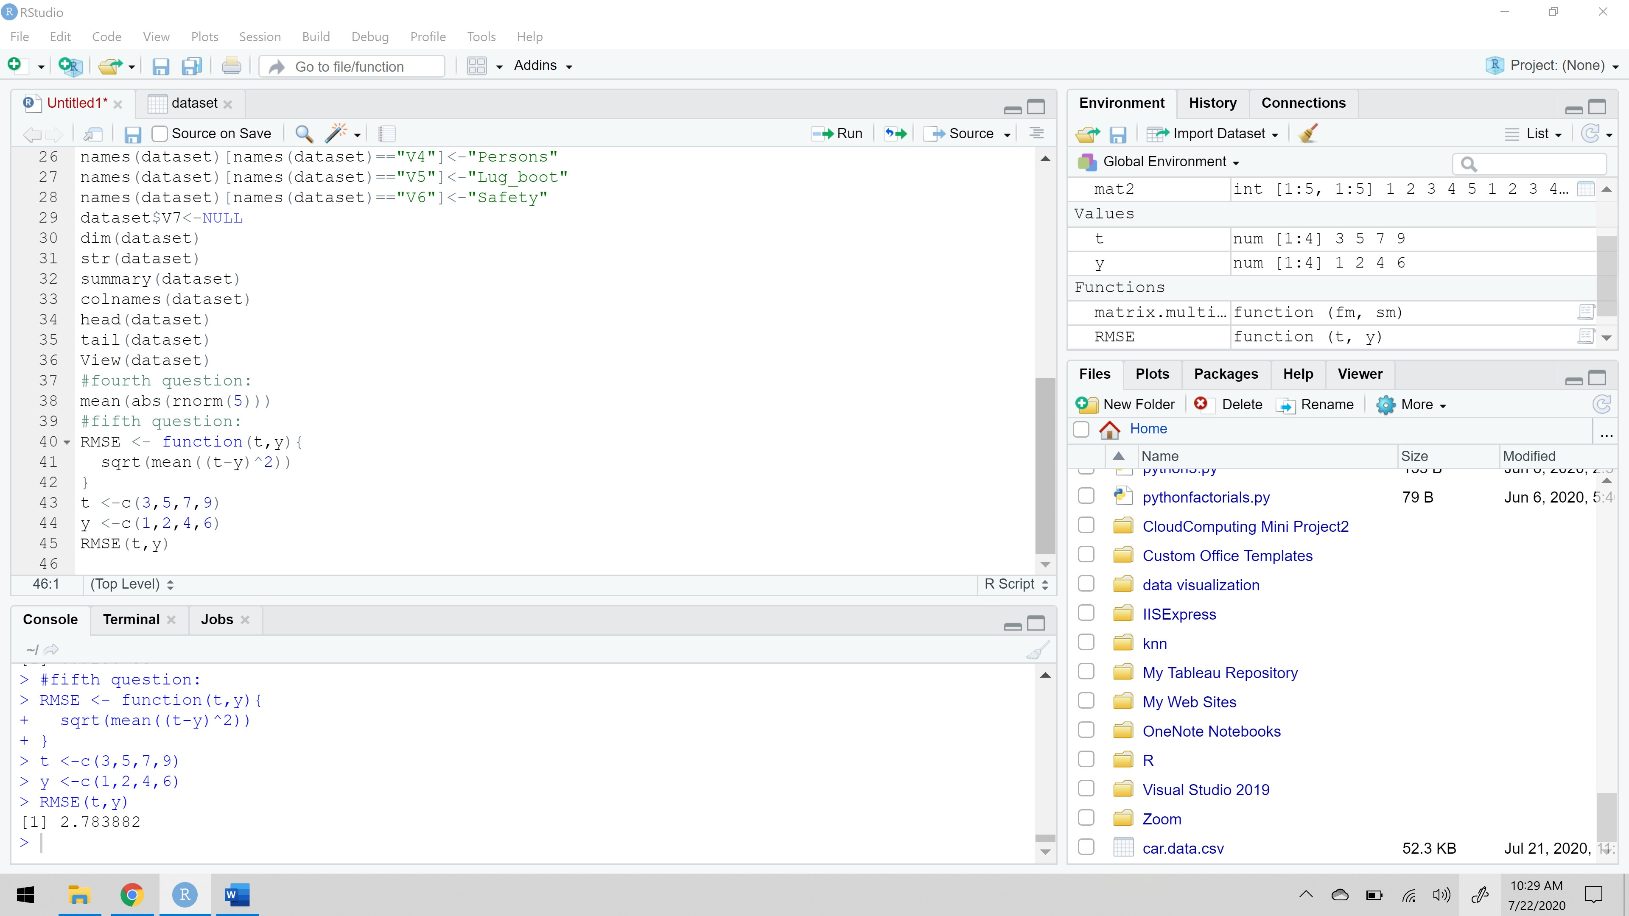

**References:**

1. <https://rveryday.wordpress.com/2016/11/29/examine-a-data-frame-in-r-with-7-basic-functions/>